Evolution Type | Scenario # | Burn # | Date
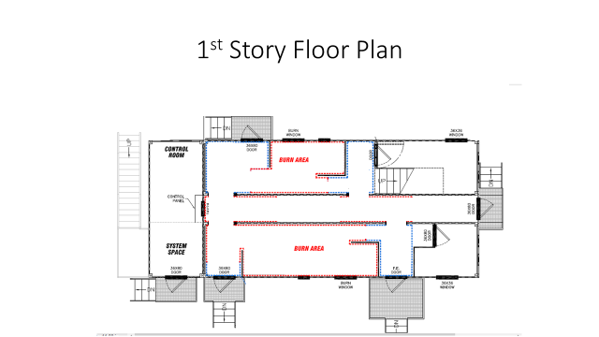

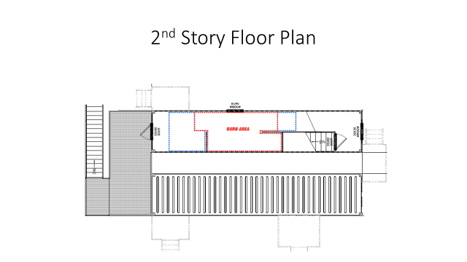

Pre - Burn Checklist
All Participants Waivers and Documentation Turn In
All Participants PPE checked including SCBA
Function Check - Doors, Windows, Vents, Latches
Trip, Slip, and Fall Hazards Mitigated including Ice if applicable
Inspect linings, air gap, and burn props
Ensure water supply - hydrant function
Separate water sources established for attack and back-up hose lines
Required fire flow determined for burn building and exposures
FIRE "SETS" PREPARED Class A Materials Only and According to the Burn Sequence Matrix Chart
Check breathing air compressor & fill cascade
Weather Report Reviewed
Instructor Briefing conducted according to Scenario.
Student / participant Briefing. (Walk thru, Evac Signal, rehab, no live victims, exits, potential victims)

Positions |  | Radio Channel
Instructor In Charge |  | Instructors
Safety Officer |  | Students
Ignition / Interior Safety |  | Evolution Time
Instructor 1 Attack |  | Time Begin
Instructor 2 Back-up |  | Ignition Time
Instructor 3 RIT / Overhaul |  | Propane Out of Building Time
Rehab |  | Time End

Post - Burn Checklist
Document any injuries - NOTIFY ON DUTY ISO IMMEDIATELY IF TRANSPORTED
Building Broom Clean - Debris in burn pans, floors swept, air space clean, squeegee standing water
Site Cleaned - All exterior debris removed
Equipment stowed - Dummies, tools, etc…
Breathing Air - Air bottles filled, cascade full, compressor off
Personal Decon and Decon of Contaminated PPE & SCBA's completed
Close & latch all doors and windows
Clean air-packs and return to service

Notes:
Signed by I.I.C. - I acknowledge the plan meets MAAC Guidelines & the intent of NFPA 1403
Printed Nave: | Signature: | Date:

