2nd Story Floor Plan |  | Crew Accountability (PAR) |  |  | Position | Assigned |  |  | Radio Channel
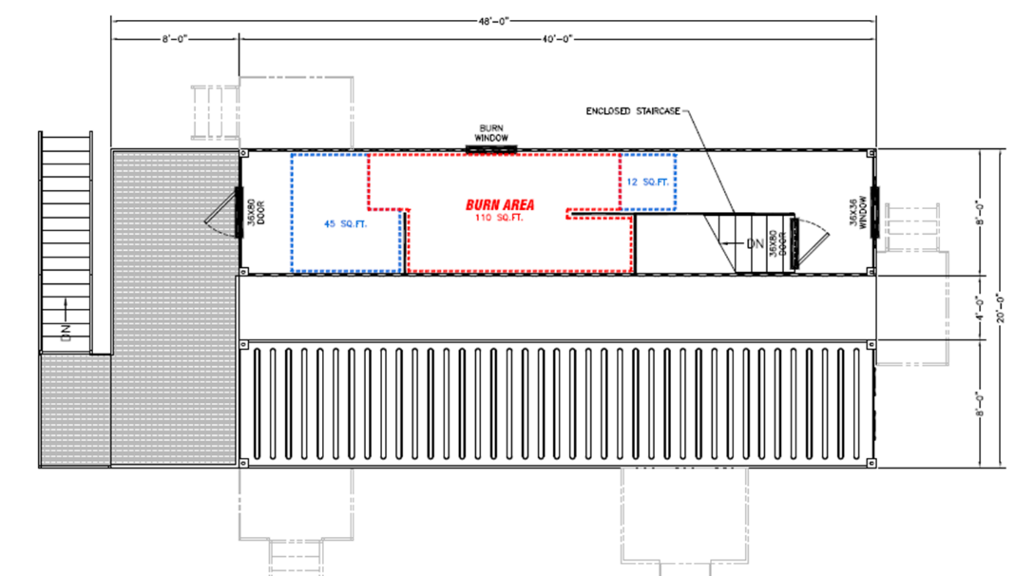 |  |  | Assignment/Name |  | Primary Positons |  |  |  | Instructors:
 |  | Group 1 |  |  | Instructor in Charge |  |  |  | Students:
 |  | Instructor |  |  | Safety Officer
 |  | Student |  |  | Ignition Officer/Interior Safety |  |  |  | Evolution Time | Time
 |  | Student |  |  | Instructor 1 |  |  |  | Time Begin
 |  | Student |  |  | Instructor 2 |  |  |  | Time End
 |  | Student |  |  | Instructor 3
 |  | Student |  |  |  |  |  |  | Assignments / Actions Completed: | Times
 |  | Group 2 |  |  | Secondary Positons |  |  |  | Go / No Go
 |  | Instructor |  |  | EMS |  |  |  | Ignition OK to Light Fire
 |  | Student |  |  | Rehab |  |  |  | Fire Ignited
 |  | Student |  |  | Logistics (Air) |  |  |  | Propane Tank Out of the Building
 |  | Student |  |  |  |  |  |  | Room Temperature
 |  | Student |  |  | Apparatus Operators
 |  | Student
 |  | Group 3
 |  | Instructor
 |  | Student
1st Story Floor Plan |  | Student
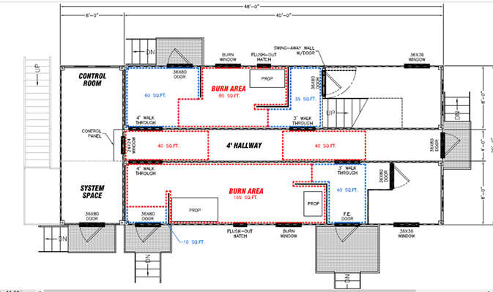 |  | Student |  |  | Go / No Go Sequence
 |  | Student |  |  | Assignments as Needed | Go | No Go
 |  | Student |  |  | Rehab / EMS
 |  | Group 4 |  |  | Attack Engine
 |  | Instructor |  |  | Safety Engine
 |  | Student
 |  | Student |  |  | Overhaul Team
 |  | Student |  |  | RIT Team
 |  | Student |  |  | Back Up Team
 |  | Student
 |  | Group 5 |  |  | Fire Attack Team
 |  | Instructor |  |  | Ignition Officer/Interior Safety
 |  | Student |  |  | Safety Officer |  |  |  | Max Burn Room Temperature
 |  | Student |  |  | NOTES:
 |  | Student
 |  | Student
 |  | Student

