Scenario 20
Upstairs apartment fire
Preparation:
100# fire set in the burn room
Safety line with ignition team
Forcible Entry door near the point of entry
Mannequin (optional)
Ventilation Prop on the roof of the 1st story (Multi-company evolution only)

Single Company Evolution
Size-Up: Command is on scene of a two story wood Craftsman Style home on a basement with smoke rising from the back side of the home. I will be conducting a 360 and establish accountability of occupants.
Update: All units the second floor appears to be its own apartment and smoke is coming from the second floor. Command will be on the North side of the building and this will be the Alpha side.
Assignments: Engine, on arrival initiate a transitional attack.

Multiple Company Evolution
For victim rescue scenarios Command/Operations should be encouraged to designate medical personnel for treatment/transport of victims. These personnel should not be included in the staffing available for fireground functions.
Size-Up: Command is on scene of a two story wood Craftsman Style home on a basement with smoke rising from the back side of the home. I will be conducting a 360 and establish accountability of occupants.
Update: All units the second floor appears to be its own apartment and smoke is coming from the second floor. Command will be on the North side of the building and this will be the Alpha side.
Assignments: Station ___, on arrival stretch to the Charlie side and reset the fire before stretching to the second floor and beginning a primary search. Station ___ lay a supply line to the attack engine from the hydrant and set up to ventilate and control utilities.
Instructions:
Ignition Team: Construct a 100# fire set in the burn room. After lighting, remove the ignitor from the building and place a movable wall in the doorway as shown in the scenario graphic. Monitor the fire and stoke it as necessary. The fire will be set ONLY on the first floor in the room indicated. A smudge pot may be used to increase the quantity of smoke.
Attack Team: Forcible entry will be done on the door prop prior to entry for fire attack. Door control should be emphasized after team entry. After extinguishment hydraulic ventilation can be considered and cooling/hydraulic overhaul can be used to cool the room.
Vent Team: (multi-company evolution) Emphasize the use of a roof ladder for rooftop evolutions on the props.
Search Team: Primary and secondary searches should be conducted. The use of victims for the scenario is optional but a live victim will never be used for a rescue scenario under live fire conditions.
Instructor Notes:
-Scenario specifics: This scenario is a low difficulty scenario with an exterior hoseline stretch to the Charlie side of the building and a hose stretch of approximately 20’ inside the building with an exterior set of stairs and a 180 degree turn outside of the building. Emphasis for this scenario should be placed on hose line deployment that allows for easy stretching and proper estimation of how much hose will be required inside the building. A Cleveland roll or Cleveland conversion can be discussed and firefighters can be shown how to advance a roll up the stairs to ease advancement. Coordination of tactical actions provides a training element for fire ground commanders and an instructor chould be assigned to mentor the leadership team as well.
-Nozzle selection will be determined by the department training but a minimum flow of 95 GPM or more must be available to attack teams.
-Students training in a Command role should be encouraged to utilize a tactical worksheet to guide their assignments and decision making.
-Personnel responsible for providing treatment to any potential injuries or victims will be identified prior to each burn. Any casualty simulations will be complete when the victim has been treated and packaged for transport.
-No fires will begin until a complete Go-No Go check has been conducted and appropriate safety supervision and medical treatment capabilities are in place.
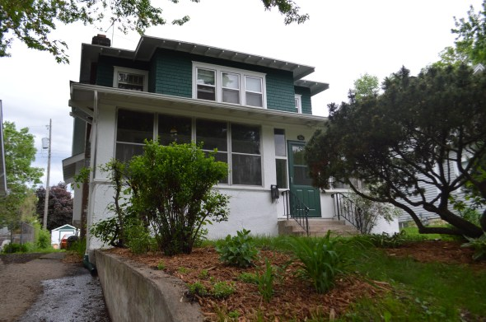
Street View ALPHA Side
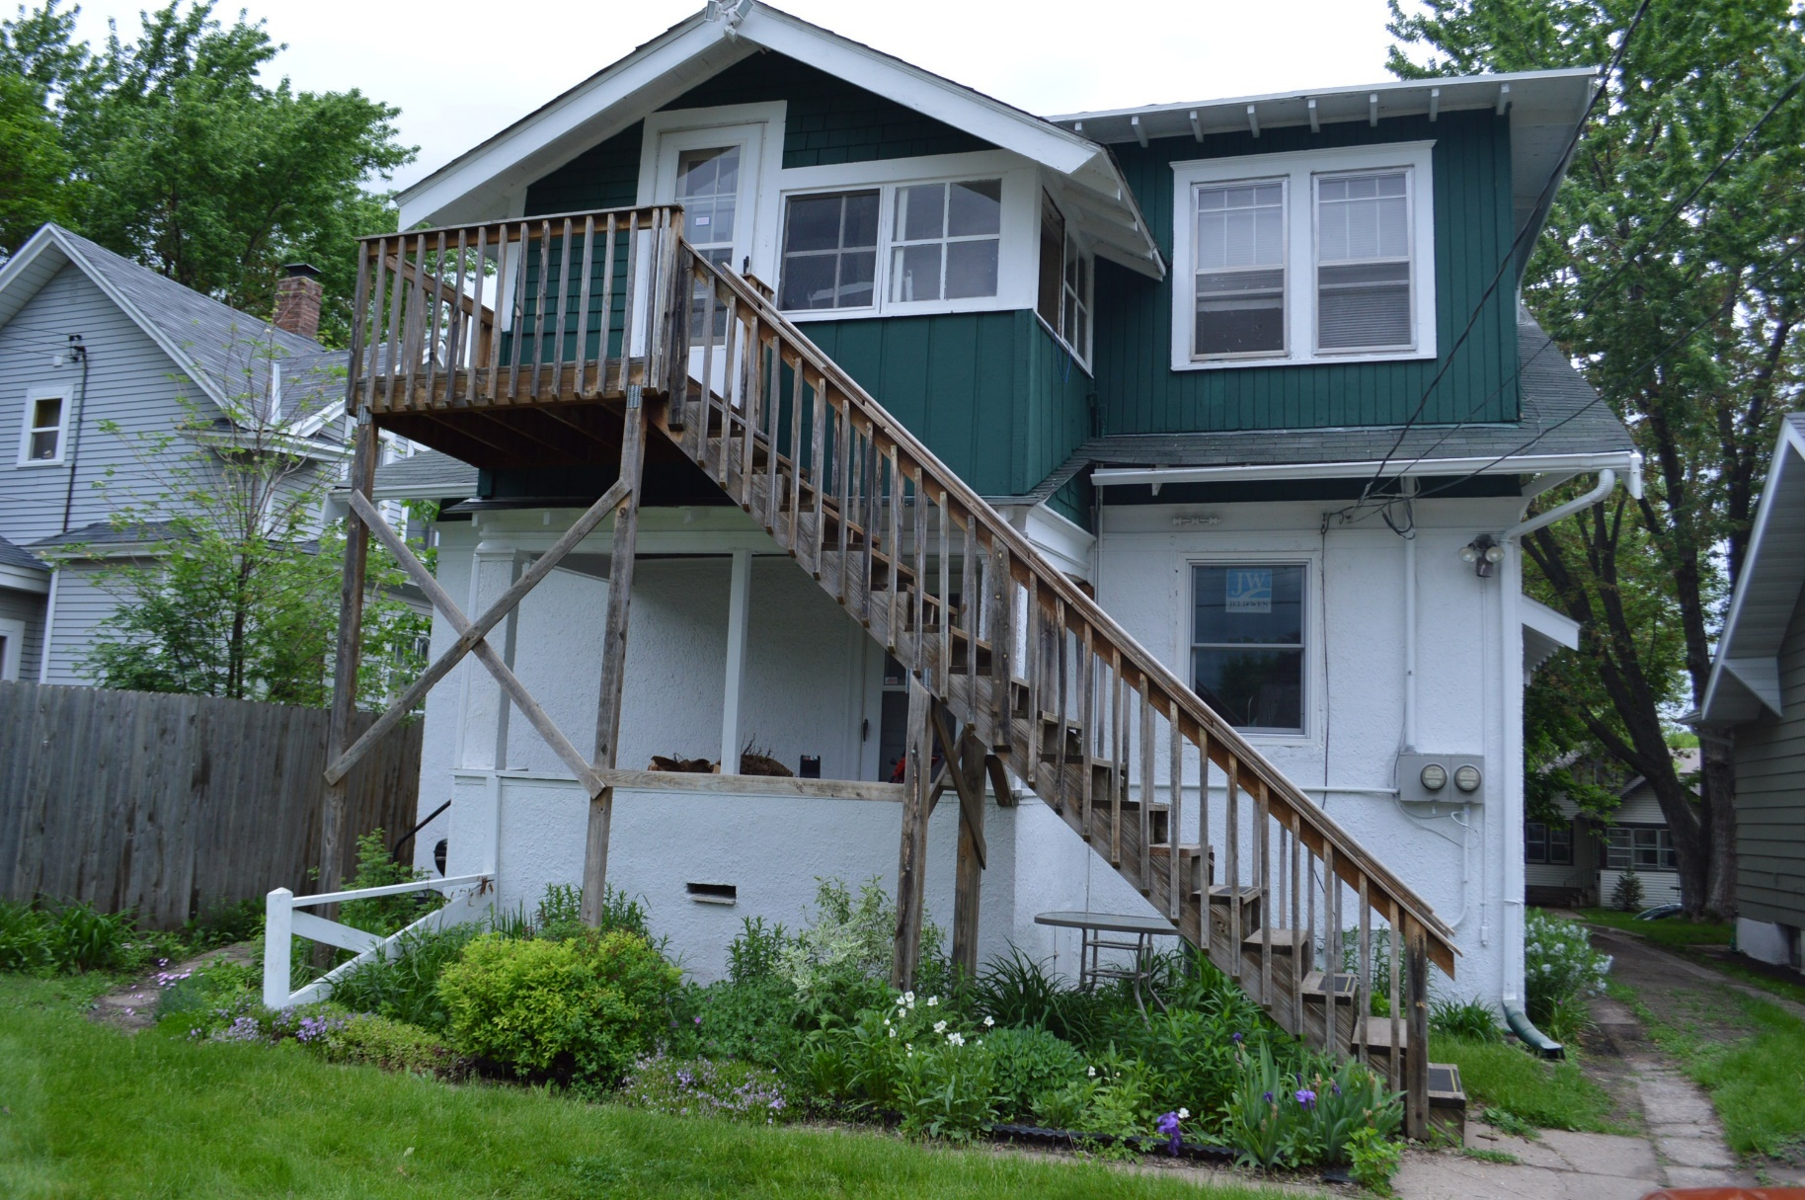
Rear View CHARLIE Side
