2nd Story Floor Plan |  | Crew Accountability (PAR) |  |  | Position | Assigned |  |  | Radio Channel
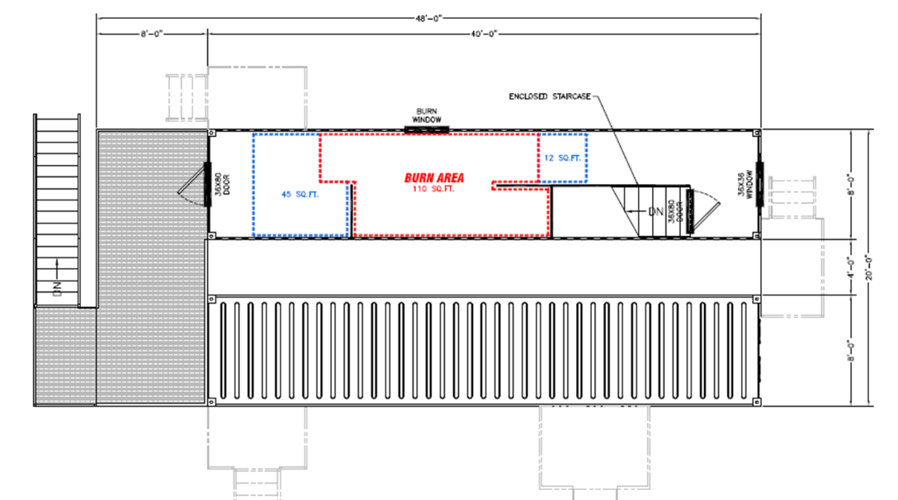 |  |  | Assignment/Name |  | Primary Positions |  |  |  | Instructors:
 |  | Group |  |  | Instructor in Charge |  |  |  | Students:
 |  | Instructor |  |  | Safety Officer
 |  | Student |  |  | Instructor 1 |  |  |  | Evolution Time | Time
 |  | Student |  |  | Instructor 2 |  |  |  | Time Begin
 |  | Student |  |  | Instructor 3 |  |  |  | Time End
 |  | Student
 |  | Student |  |  |  |  |  |  | Assignments / Actions Completed: | Times
 |  | Group |  |  | Ignition Team |  |  |  | Go / Stop
 |  | Instructor |  |  | Ignition Officer
 |  | Student |  |  | Ignition Observer |  |  |  | Ignition OK to Light Fire
 |  | Student
 |  | Student |  |  | Secondary Positions |  |  |  | Fire Ignited
 |  | Student |  |  | EMS
 |  | Student |  |  | Logistics (Air) |  |  |  | Propane Out of the Building
 |  | Group
 |  | Instructor |  |  | Apparatus Operators |  |  |  | Send Attack
 |  | Student
1st Story Floor Plan |  | Student |  |  |  |  |  |  | Room Temperature
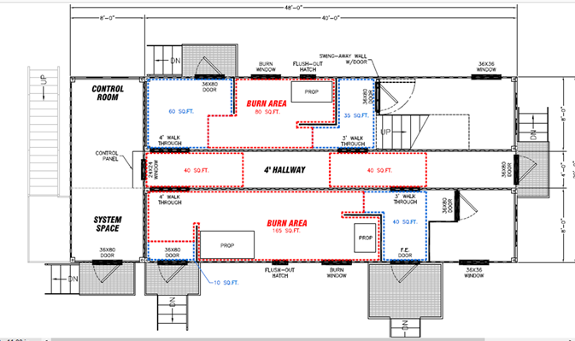 |  | Student |  |  | Go / STOP Sequence
 |  | Student |  |  | Assignments as Needed | Go | STOP |  | Water on The Fire
 |  | Student |  |  | Fire Attack Team
 |  | Group |  |  | Ignition Officer/Interior Safety |  |  |  | Fire Struck
 |  | Instructor |  |  | Back Up Team
 |  | Student |  |  | Overhaul Team |  |  |  | Overhaul
 |  | Student |  |  | RIT Team
 |  | Student |  |  | Rehab / EMS |  |  |  | All Companies Out
 |  | Student |  |  | Safety Officer
 |  | Student |  |  |  |  |  |  | Evolution Complete
 |  | Group |  |  | Attack Engine
 |  | Instructor |  |  | Safety Engine
 |  | Student |  |  |  |  |  |  | Max Burn Room Temperature
 |  | Student |  |  | NOTES:
 |  | Student
 |  | Student
 |  | Student

